Armor Soldier Readiness Book

Prepared by MSG (ret.) Randall High

Armor Soldiers are usually very organized. One way to help organize and keep your Army documents in order is to create a Readiness Book. Once you get the book developed you can insert documents into the appropriate sections throughout your career as you receive them. Having a Readiness Book will make it easy for requirements such as: readiness briefings, records reviews, ERB updates etc…

Armor NCOs may want to consider directing their soldiers to develop and maintain an Armor Readiness Book. This will make it easy for you when you are doing things like: soldier counseling, preparing promotion packets, award recommendations and during preparation for deployments.

How to make an Armor Soldier Readiness Book.

- Acquire a good quality 2 inch binder. One that can endure rough treatment during travel to various duty stations and deployments. Some soldiers may want to select a binder with a zipper to help keep out sand.

- A table of contents is provided in this section. You may want to copy and save it to your computer so you can make changes and/or additions as new forms/documents are required during your career.

- Choose high-quality document protectors.

- Select tabs or dividers that will extend beyond the document protectors.

- Acquire a loose leaf notebook pouch (w/three holes and a zipper). The pouch is needed to hold your deployment items such as: spare ID Tags, Immunization Record, and Passport.

In addition there is a sample Biographical Data Sheet in this section. The Biographical Data Sheet is used by the soldier’s sponsor for promotion and Soldier/NCO of the Month Boards etc. It is also item 1 on the Readiness Book table of contents.

Armor Soldier Readiness Book

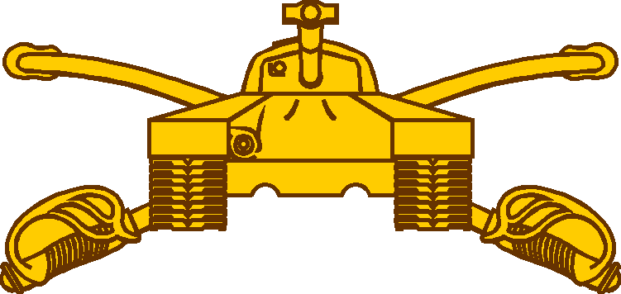

Name: _________________________________

Unit: __________________________________

Platoon: ________________________

Armor Soldier Readiness Book

Contents

Document TAB
Biographical Data Sheet ….....……………………………………………………….... 1
Awards and Decorations w/Orders and/or DA Form 368 …………………………... 2
Certificates of: Training, Achievement and Appreciation ........................................ 3
Clothing Records ………………………………………………………......................... 4
College Transcripts …………………………………………………………………........5
Correspondence Course History …………………………………………………........ 6
Counseling Statements ………………………………………………………….…..…. 7
DA Form 348 Equip. Operator’s Qualification Record ….…………………………… 8
DA Form 705 (PT card) and DA Form 5500 (Body Fat worksheet) ....………………9
DA Form 1059 from NCOES Courses ………………………………….………………10
DA Form 3355 Promotion Point Worksheet ……………………………………………11
DA Form 3685 JUMPS Pay Elections (from first enlistment on)…………………......12
DA Form 4872 Certificate of Promotion with Orders ...……………………………....13
DA Forms for Record of Weapons Qualification …..……………...............................14
DD Form 93 Record of Emergency Data .……………………………………………...15
DD Form 1172 DEERS Enrollment ……………………………………………………..16
DA Photo …………………………………………………………………………. ………17
Enlistment and Discharge Certificates ...…………………………………………….....18
Enlistment Contracts ………………....…………………………………………… …….19
ERB (updated copy) ………………………………………………………………………20
Letters: (letters of: accommodation, appreciation etc) ....…………………………..... 21
NCOERs …………………………………………………………………………... ……...22
Promotion Orders ………………………………………………………................. …….23
PCS Orders ……………..……………………………………………………………....... 24
Orders (Collateral Duty)...…………………………………………..……………... …….25
Other Orders .………………………………………………………………………………26
SGLI Election Form ……………………………… …………………………………… 27
Will …………………………………………………………………..…. ………. ………...28
Marriage Certificate ……………………………………………………………………… 29
Birth Certificate(s) (soldier and dependants) .………………………………………… 30
Power of Attorney ……….………………………………………………………………. 31
POV Registration and Insurance Info …..……………………………………………… 32
Miscellaneous Hand Receipts and Documents … …………………………… annex 1
Deployment Pouch ………………………………………………………………. annex 2
- Immunization Record
- Passport
- HIV Status Report
- Spare Set of ID Tags

1.

Armor Soldier Biographical Data

Rank/Name:
SSN: (last 4 numbers)

AKO email Address:

Duty Position: (driver, loader, gunner, tank commander etc…)
Additional Duty: (CBRN NCO, EO NCO etc…)

Primary MOS: (complete MOS example:19K3HA8)

Secondary MOS:

Unit and Phone Number:
Mailing Address:
Hometown:
Marital Status:
Name of Spouse:
Name and age of Child(ren):
Military Education: (give the exact name of the schools and locations)

Civilian Education: List degree that you are pursuing or have completed (A.A., A.S., B.A., B.S. etc … and the name of the university, college or technical school)

Awards and Decoration: (list the award and then the number in parenthesis. example: Good Conduct Medal (1) representing the first award. Badges are only received once therefore no number is required).
Assignment History: (unit/post/state/country)

Significant Accomplishments:

Hobbies and Interest:

2.

